2016 Annual General Meeting (AGM) Package last modified 23-Mar

  - Greetings and Introductions

Good evening and welcome to the MTFL’s 45th AGM. On behalf of the 2015 Executive Committee, I would like to welcome the team representatives of the veteran and candidate new teams as well as all other invitees and distinguished guests here in attendance tonight.

If present, introductions to persons representing the following organization’s will now be made:
- Mississauga Officials Association (MOA) executive
- Touch Football Ontario (TFO) executive
- Mississauga (Youth) Football League (MFL)
- league sponsors and partners
- members of the media

The MTFL was established in 1982 and it remains a non-registered, non-incorporated, not-for-profit sports organization committed to the principles of transparency and member delight as well as fulfilling its mission statement of providing organized touch football in a safe, competitive and fun environment.

This evening’s meeting will proceed as follows:

Agenda Item | Expected Duration | Summary
A | 45 minutes | Main Meeting:  All team representatives must attend.  Please note, only the captain of record (or his designate) of veteran team’s in good standing will be allowed to vote on any tabled issue.
B | 15 minutes | Questions and Answers:  All team representatives should attend.  Please note that the responses to some questions may be deferred as they might be identified as pertaining to information that is intended to be discussed during the Supplementary Meeting OR they might be tabled by the Executive Committee for consideration during the season itself.
C | 30 minutes | Post AGM Supplementary Meeting:  All new team applicant representatives must attend but any other persons invited to this AGM may also attend.  More specific details about the league, its organizational requirements, planned events and proceedings will be discussed.
Main Meeting Proceedings begin

The first order of business for tonight’s meeting is to establish the members of the MTFL 2016 Executive Committee who will hold decision-making powers and voting rights within the committee.

- League Executive

  - The proposed members

  - with voting Executive Committee privilege:

John Schiebel : for President, Registrar and Director of Record Retention.

Glenn Stevenson : for Vice-President, MOA Liaison, Scheduler and Director of League Communications.

Matthew Vincent : for Director of Finance and Director of Discipline.

A vote to accept the above will now be conducted. Only one representative of each veteran team in good standing may vote.

Those for: Those Against:

  - without voting Executive Committee privilege (aka “Executive Committee members at large” who offer service to the voting executive or members of the league itself for areas including but not limited to: website construction /maintenance /automations, marketing, photography and/or serve as a disciplinary committee member or a divisional “rep”):

John Avarino

Dan Ward

Jon Schoutsen

Jeff Hubert

Mary Kennedy

Lola Nelson

Volunteers are always welcome.

One can assist the league in many ways, including being an executive committee member with a particular portfolio or volunteering for specific tasks valued by this league:
- Game Result and Roster Data Input
- Photography
- Special Projects & Events (e.g., yearbook, skills competition, year-end party)

A volunteer to this league is expected to contribute between 8 to 30 hours of their time per season.

Compensation will be considered for effort or expense that occurs in excess of what the Executive Committee would reasonably expect a volunteer to perform or encounter. This may occur for various reasons: small number of volunteers, inexperienced volunteers, tasks that are time consuming, tasks that are being performed by the same volunteer.

Compensation may be in the form of pre-approved expenses (to attend a seminar or conference), meal or mileage allowance or even an hourly rate. For 2016, the value of:
- any hourly rate based compensation awarded will range from $12 to $16 per hour based on the type of task (clerical, technical) or the skills and equipment needed/provided.
- mileage, if offered, must be pre-approved and will not exceed $0.50 per km.

Any hourly compensation awarded as financial payment from this league is to be considered as non-reportable income (because the MTFL is a non-registered, non-incorporated not-for-profit sports organization).

Compensations may be awarded in a lump sum amounts or awarded incrementally as the approved work proceeds or as it is verified or accepted by the voting members of the Executive Committee.

At this time, the Executive Committee expects no one single “volunteer” this season to be awarded more than a total of $1000 for any of the league’s tasks envisioned or felt suitable for financial compensation.

If you have benefited from the MTFL through hours of enjoyable and memorable recreation, perhaps now it is time for you to consider giving back to the league.

The MTFL is in need of more volunteers. Please see any of the Executive Committee members after tonight’s meeting has concluded if you are interested in helping to run this league.

- Proposed Constitution and Bylaw Changes

From time to time circumstances may arise driving a need to revise the league’s mission statement, strategic plan, constitution, bylaws or policies. The 2016 Executive feels no such circumstance exists this year.

Furthermore, although constitution and bylaw change proposals do exist (and reflect minor typographical clarifications identified by members of the league as well as the executive team over the last two years), at this time, the executive team also feels that correcting any of these items is not imperative. As such, no changes whatsoever to the existing constitution or by-laws are proposed for tonight’s AGM.

The league’s strategic plan is included in this AGM package. The Executive team feels that none of these items require any revision for the upcoming season. Also, and new to this year, the MTFL intends to construct a “operational best practices and decisioning” guideline. This guideline is not binding but it is to be used through out the season as typical practice and behaviour for gaining constructive as well as long-term benefits for this league.

- Proposed SCHEDULING PARADIGMs and PRACTICES
This year, the executive wishes to offer some “Saturday” morning game dates in the regular season for any teams interested. Furthermore, whether such a game is scheduled in advance OR arranged for during the season due to some in-season re-scheduling need or request, the league will reserve one Saturday field location (with up to three games per each reserved date).

Although, no teams are “obligated” to play a regular season game on Saturday, it may prove the case due to other in-season field or referee crew or opponent availabilities, the league strongly suggests such a re-scheduling occurs. For example, a very much possible and reasonable reasoning for such a request from the league could be to ensure that the overall regular season (or play-off) schedule start and end dates are kept. That is, the league could request teams to play Saturday as a resolution to any in-season schedule disruptions.

The league will not attempt to schedule play-off games on any Saturday save an extreme (in play-off time) situation of field or referee availability. That is, and in specific, all are forewarned that any request by a team for a play-off game to be held on a Saturday is more than likely to be declined for the 2016 season.

A scheduling preference form is available for each team to complete. Please do so by the conclusion of this meeting.

A vote to identify those teams supporting such a (league wide master) schedule plan and re-plan mitigation approach will now be held.

Those For: Those Against:

- Other Business

The Executive Committee intends on:

- investigating waiver and code of conduct changes including the possibility of amalgamating these two documents into a single entity. This effort is anticipated to be completed before the start of the regular season (e.g., `mid-May-2016).

- assisting Touch Football Ontario (TFO) in finding and deploying an on-line team and player registration system. This effort may involve the use of software previously created and owned by the MTFL or it may involve other 3rd party software provided to MTFL by TFO. The immediate part of effort is due before the EARLY BIRD tournament. For example, TFO wishes to have an electronic capture of every player’s own acknowledgement to (TFO) waiver as well as that player’s name, contact info (e.g., address, phone and email) as well as league , division of play and team name in on-line database.

- supporting an initiative byTFO towards the creation of that organization’s own constitution, bylaws and policies. That activity may generate further changes towards MTFL’s own constitution and bylaws. However, the changes for the MTFL’s constitution and bylaws coming out of this effort are expected to be presented to all league members before the 2017 AGM.

The MTFL executive will continue to ensure that any changes to the Constitution and/or Bylaws of TFO remain consistent with the particulars of this league’s current articles and practices.

Unfortunately a draft of those TFO documents has not yet been sufficiently articulated nor vetted for any further discussion upon during tonight’s MTFL AGM.

Persons interested in assisting in the construction or review of these materials should make themselves known to Glenn Stevenson and John Schiebel before the conclusion of this MTFL season (~Sep-2017). They may also contact TFO executive representatives (e.g., Mr. Steve Morrell or Mr. Russ Henderson) directly (using the contact information posted at www.tfont.com ).

- Standings/Play-off Results and Year-End Awards

Let’s recognize the achievements of our teams and players from last season:

Division 2015 Championships
AA Piranhas
A Cobras
B Axemen
C Renegades
D Raiders
E Onyx
The play-off game (bracket) and regular season results for each division were:

AA Division

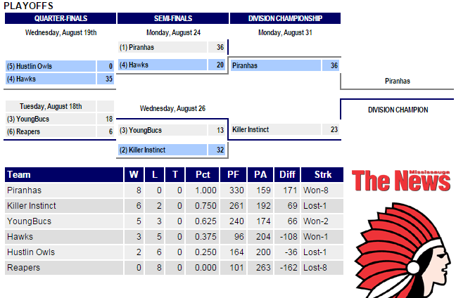

A Division
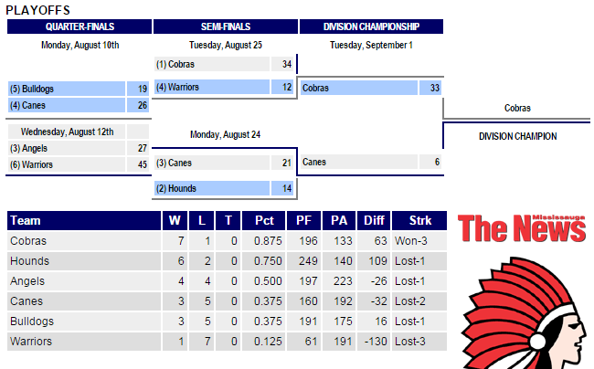

B Division
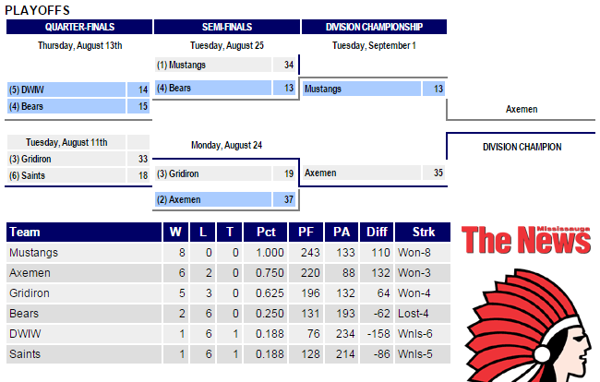

C Division
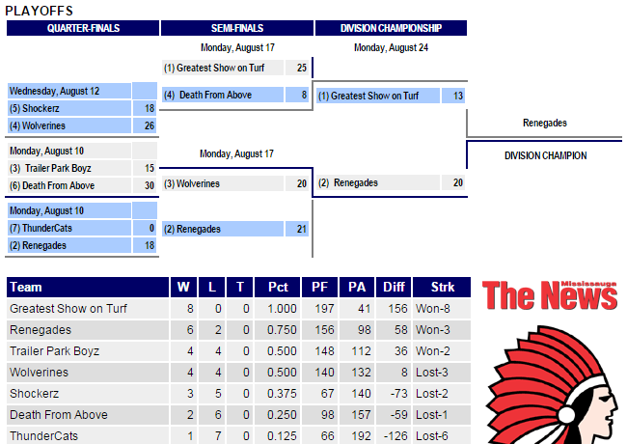

D Division
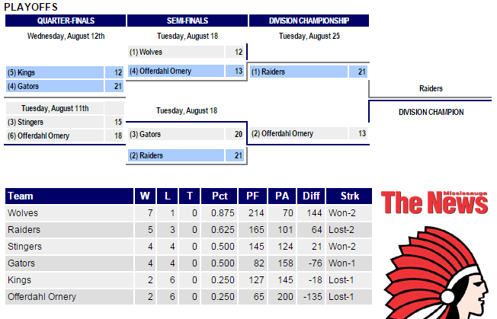

E Division
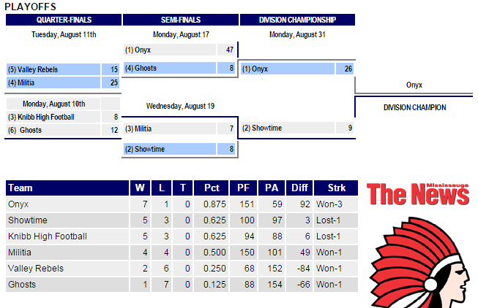

Based on the tabulated votes of the submitted game sheets of each regular season game, let’s also recognize the Most Valuable Player and the Most Sportsman like players from our last season:

Division | MVP 2015 | Sportsman 2015
AA | Jay Hayes  (Piranhas) | Nevin Blair  (Piranhas)
A | Damien Crone  (Warriors) | Joey Skinner  (Cobras)
B | Ashton Nelson  (DWIW) | Ian Simpson  (Bears)
C | Kevin Logan  (Renegades) | Sinh Nguyen  (Shockers)
D | Triston Hackett  (Raiders ... Kryptonite) | Brian Merker  (Offerdahl Ornery)
E | Rodney Charles  (Onyx) | Karim Kolia  (Valley Rebels)
 | and from other recent seasons ...
Division | MVP 2014 | Sportsman 2014
AA | Marko Glavin  (Killer Instincts) | Delroy George  (Killer Instincts)
A | Derrick Ogden  (Warriors) | Peter Hoang  (Super Troopers)
B | Chadwin Bartley  (Saints) | Wayne Dimaline  (Axeman)
C | Kyle Badham  (GSOT) | Tharsan Sivaramalinghan  (ThunderCats)
D | Dieter Kusel  (Stingers) | Warsame Garad  (Raiders)
Division | MVP 2013 | Sportsman 2013
AA | Adrian Ferenc  (Reapers) | George Ioannides  (Hawks)
A | Ryan Bachelor  (Canes) | Vic Carvalho  (Rack)
B | Ian Simpson  (Bears) | Gordon Shantz  (Super Troopers)
C | Sutharsan Sivasoothalingan  (ThunderCats) | Kevin O'Carroll  (ThunderCats)
D | Dieter Kusel  (Stingers) | Joe Kincaid  (Stingers)
Division | MVP 2012 | Sportsman 2012
AA | Josh Granek  (Cobras) | Devin Henry  (Spartans)
A | Melios Arsic  (Canes) | Justin Tang  (Canes)
B | Chris Rauch  (BullDogs) | Daryl Brady  (Bears)
C | Ben Bilz  (Hounds) | Phil Attrell  (Wolves)
D | Mark Mlakar  (Delta Squad) | Bill Chan  (Arrows)

  - 6. League Finances

League finances are in an acceptable state. As of 31-Dec-2015, the league’s bank account cash on hand balance was $3305.92.

- Approximately $450.00 of that amount has been spent in order to finalize the reconciliation of other expenditures needed and approved before tonight’s AGM. Specifically, expenses for room and equipment rental, printing costs, Executive Committee meetings, life-time/special awards, software tooling/licenses, etc.

- For comparative purposes, the league’s bank balance as of 31-Dec-2014 was $7244.61.

- The 2015 closing balance is lower than that of 2014 as some of the in-season expenses as well as refunds issued to teams were larger than forecasted within the 2015 AGM package. Furthermore, in-season revenues (and in particular, revenues for hosting the 2015 Brampton Trillium Tour event were less than typical. In specific, both days of the May-2015 Trillium Tour event in Brampton were disrupted by wind or rain and the daily temperatures were not encouraging of the typical amounts of food and beverage sales enjoyed at “warmer/sunnier” tournament events hosted by MTFL in the past).

- The Executive remains committed to providing, when warranted or appropriate, refunds to each team at the conclusion of a season. For example, should the league itself reduce the number of games made available, the league will compensate the implicated teams (at ~$100 per game each). Also, should any other forecasted or in-season financial actual expenditures create larger than reasonably needed surpluses (e.g., in excess of $5k total), such excessive funds will be refunded no later than the conclusion of the season in an amount that is proportional to each of the teams in good standing.

The unaudited accounting of the league’s 2015 actual expenses is presented in the following two exhibits:

AGM-Exhibit: General Ledger At Close Of Previous Season (as of 12-Feb-2016):

AGM-Exhibit: 2015 Cash Flow Analysis and 2016 Expense Mitigations (as of 12-Feb-2016):

The financial forecast for the upcoming 2016 season is based on having a league of 26 teams. Total revenue forecasts are restricted to mandatory team fees only, with each team paying the $1800 team registration fee.

AGM-Exhibit: Budget Forecast For The Upcoming Season (with worst case of 26 total teams)

Each team’s registration fee of $1800.00 is payable in full prior to the conclusion of this meeting. If payment in full of the team registration fee is late, an additional $200 late fee charge is required. Late fee charges must be paid in full before the release of league’s schedule which is anticipated no later than two weeks prior to the start of the season (which will be no earlier than 06-May-2016).

If a cheque-based payment is submitted on time, but subsequently fails to clear the bank, the above late fee may be applied. Regardless, a “bounced cheque” processing fee of $50 will be applied by the league to the offending team no matter what.

As usual, league size and composition is highly dependent on field and referee availability. At this point, the Executive Committee is hoping to have between 26-32 teams for the 2016 season and believes a sufficient number of field locations are available to operate.

At this time, the league is not forecasting any situation in which significant (e.g., more than $50 per team) in refunds will be made available at the end of the season. Furthermore, for the 2017 (next season of play), the Executive is forecasting that a registration fee price increase (of at least $100 per team) will be necessary to account for its desire to compensate referees fairly and reasonably.

New for 2016, payment of league fees may be done by on-line bank email transfer to mtfl_mississauga@yahoo.ca ; please use your something like “MTFL-yourteamname” (e.g., “MTFL-Bears”, “MTFL-Axemen”) with no quotes and no spaces as the password for the league to enter to accept such an e-transfer payment. Also, please use the name of your team exactly as it appears on the league’s website.

  - 7. 2016 Season – General Planning Particulars and Highlights

  - Team Roster – notification of change in roster (additions, deletions):
    - maximum 20 players; minimum 12 (league encourages at least 14)
    - game suspensions will be awarded for playing ineligible / unregistered players

New for 2016, team roster size has been reduced from a maximum of 21 to 20 players. This change is being set as a requirement of the MTFL in lieu of its understanding of its liability insurance obligations held with TFO (and the under-writer thereof). Specifically, TFO is encouraging overall roster sizes to shrink (to 20 this year and 19 the year after this) in order to foster whole new teams within leagues and tournament play. MTFL interprets this roster size reduction as both a cost-benefit factor (for its own pricing strategies and practices) as well as legal liability.

  - Player Registration & Waiver Form:
    - all players new to the team need to fill it out
    - all players must be 18 years of age and male
    - may only be registered with one MTFL team
    - must meet playoff eligibility in order to play in playoffs: played (in attendance) at 3 reg. season games, 1 of which is in team’s first 6 games

  - Team Captains’ Responsibilities:
    - managing the team’s roster according to the League’s Team Roster Policy
    - communicating to the League any team roster changes (player additions or deletions)
    - ensuring each player has completed a Player Registration & Waiver Form and that it is on file with the League
    - promoting the League’s emphasis on ‘providing organized touch football in a safe, fun, competitive environment’
    - showing respect for officials and the difficult job they perform
    - ensuring players know the League’s touch football rules
    - ensuring players and fans know and abide by League rules and policies
    - ensuring the team is prepared to play each scheduled game:
    - members know when and where their next game is
    - members know how to access the league schedule online
    - game equipment is brought to each game (football, kicking tee, goal post pads, and numbered uniforms)
    - submitting the completed, current game sheet to the Head Official
    - being receptive to schedule changes – they are done only when necessary

  - 8. MEMBER Conduct

- Motto – providing organized touch football in a safe, fun, competitive environment.

- All members are to abide by the league’s Code of Conduct:

AGM Exhibit: Code of Conduct

- Player conduct before, during and after a game are subject to discipline.

- Ejection:
  - 3 OC’s same game – automatic ejection
  - an ejection does not require 3 OC’s; specifically, safety issue or player in-eligibility issue can be resolved via immediate ejections
  - players ejected may be asked to leave the game site
  - ejection involves suspension for future play until further notice (league disciplinary committee investigation)

- All players should shake the hands of the opposition as well as the officials at end of the game.

  - 9. Mississauga Officials Association (MOA) Updates/Feedback

- MTFL has a long-standing relationship with the MOA:
- positive and frequent dialogue, communication, and planning.
- George Zielinski and Peter Cover will be running training clinic prior to the start of the season. They will also be conducting assessment of as many as 30 different referee crew assignments during the season.
- If interested in joining the officiating group, please contact George Zielinski.
- Officials Incentive Program –for new player-referees - $75 over each of first 2 years - $150 total.
- Quality Assurance Program – evaluation program for referees – to improve quality and consistency of officiating.
- OA Liaison – Glenn Stevenson – contact to communicate questions and concerns.

The MTFL is willing to, for the betterment and consistency of the field of play, assist in bulk purchases of field cones, bean bags, etc. for referees who complete MTFL game assignments.

The MTFL now invites the MOA executives for a brief summary of any updates or other concerns and feedback or announcements of upcoming referee training clinics they may wish to share this evening.

  - 10. City and Field Permits

At this time, the Executive Committee holds an informal and non-guaranteed understanding with the City of Mississauga that it will award a profile of field locations and game dates similar to that of the 2015 season. TBD (e.g., further commentary if any further late breaking information from city of Mississauga Parks & Rec groups becomes available the day of the AGM).

MTFL Executive committee continues to monitor the City of Mississauga about future field asset needs including the use of lit fields (whether grass or turf based). Again, at this time, the only issue to report is that Wildwood Park (e.g., Derry and 427, grass based) and Saint Marcellenius High School (e.g., Mavis and 401, turf based) remain plausible options. However, no further information has been provided by the City to this league on any new sports complex facility at “area 454” (Derry and Ninth line).

Finally, all league members are reminded that a turf-field location has more than ten times the cost to rent then compared to any of the league’s grass field locations currently requested for use in the City of Mississauga.

  - 11. Marketing & Social Media

The league wishes to continue building / sustaining partnerships in the community for its promotional or operational needs:
- Chop Shop Sports
- Mississauga News
- T. Litzens Sports
- And potentially new for 2016, SUB-In Sports

The league also wishes to sustain a presence for social media (e.g., Facebook, Twitter and its website itself) as well as offer its members opportunities off the field (e.g., year-end party).

If you are interested in helping the league as a supplier, sponsor, advertiser or as person capable of “tweeting” league news and game results, please let the Executive Committee know that.

If you use, forward or make comment upon league announcements made thru social media or otherwise, be sure that your comments are not offensive or in poor taste. For example, comments should remain in-line with the league’s motto. Remember, that these forums are public ones. If you wouldn’t want your employer, parent or child reading it, then don’t write it.

All are encouraged to promote the MTFL positively through these mechanisms to their team-mates, fans and the community as a whole.

In matters pertaining to or originating from the MTFL, inappropriate use of social media will be subject to league discipline.

  - 12. Other News of Interest

- TFO has continued with last year’s change in eligibility requirements for persons wishing to attend a Trillium Tour event. For example, “hybrid” (or “merged”) teams will be allowed in tournaments under some conditions and subject to some restrictions. MTFL “E”, “D” and “C” and “B” division based teams who have players interested in tournament action should contact league executive so they can be matched with other groups of players of other MTFL teams for possible combined entry to any number of tournaments that they may wish to participate in this season.

- In addition to TFO’s changes to tournament eligibility requirements, TFO also wishes to grow league member awareness to tournaments by asking leagues to consider scheduling (at least) one of their regular season games (from each of their divisions of play for which most teams currently do not participate in a tournament) at a local tournament. Similar to last year, TFO has asked MTFL to consider scheduling one its regular season games at “Brampton, May-2016” (28th or 29th).

A vote to identify each team’s willingness to accept this request from TFO will now occur. Only one representative of each veteran team (of each division implicated) in good standing may vote.

This vote is predicated on MTFL executive ensuring that the playing conditions as well as costs of play are acceptable (e.g., similar to those of having this game played at normal MTFL game location at a normal evening of its Monday to Thursday offering) before any attempt to schedule such games.

Again, this game, should occur, is likely to be placed on the “Sunday” of the tournament (due to field availabilities prioritized to the tournament teams themselves).

From MTFL’s 2015 Div-B … Those For: Those Against:

From MTFL’s 2015 Div-C … Those For: Those Against:

From MTFL’s 2015 Div-D … Those For: Those Against:

From MTFL’s 2015 Div-E … Those For: Those Against:

- MTFL intends on serving as host for Trillium Tour “Brampton, May-2016”. Volunteers are welcome especially those persons with “Smart Serve Card” capability. Persons interested are to contact John Schiebel by 15-Apr-2016. Adult persons with SMART SERVE credentials are preferred.

- MTFL is considering hosting a TEXAS HOLD’em Poker Tournament (in late April or early May). Co-sponsoring teams or work places are welcome (for sourcing of “graft” prizing as well as proceeds sharing purposes). Persons or teams interested are to contact John Schiebel by 15-Apr-2016.

- Further MTFL web site automations for on-line player and team registration will be deployed this year. Team captains wishing to help develop or verify these automations and are familiar with MS 365, Perl scripting and HMTL should contact John Schiebel or Matthew Vincent by 15-Apr-2016.

  - Main Meeting Proceedings concluded

At this point, the floor is opened to questions or feedback from any person in attendance.

The Executive Committee reserves the right to defer a question (and/or the responses to it) to sometime after tonight and/or to the already next scheduled portion of tonight’s agenda being used for the communication of other more routine league details and concerns.

For those not wishing to remain after this question and answer period has occurred, a brief break will be held so you can dismiss yourselves from the room without interrupting the remaining proceedings planned for this evening.

B. Post AGM Supplementary Meeting begins

Other League Details and Particulars

      - Games

- Rules
    - uses Touch Football Ontario rules; however, there are some additional rules specific to MTFL:
        - 4 by 18 minute quarters
        - incidental head touch – 5 yard (versus 15 yard for non-incidental)
        - minimum player count to start game (6 players)
        - playoff entitlement
  - Game Sheets
    - use current sheet from the league’s website
    - submit game sheet to referee at half-time –only those present at time of game sheet submission are registered as ‘present’
    - players who arrive after game sheet submission may play but do not get credited with being in attendance
    - verify score at end of game
    - choose MVP and Sportsman for other team
    - captain signs sheet
  - Equipment
    - Goal Post Pads – mandatory
    - Team Uniforms – see Uniform/Jersey Policy

AGM Exhibit: Uniform Policy

    - Hard substance braces – must be fully covered (by soft material/wrap)
    - Jewelry – take it off or cover it fully with tape (as to reduce chances of injury to self or others)

  - 14. Divisional Alignment

Divisions are aligned based on several factors such as:
- the addition of new teams or the disbanding of veteran teams
- recruitment or loss of players by veteran teams
- performance and results from the previous season(s) in the MTFL
- performance in tournaments and other leagues
- team captain’s input on his team’s anticipated performance
Alignment of all divisions will be announced at least two weeks before the season starts.

  - Scheduling
Well in advance of the start of the regular season, each team should fill out the team schedule preference form.

AGM Exhibit: Schedule Preferences Form

The league will do its best to accommodate requests depending on other teams’ requests and various other factors. However, there is no guarantee that any or all of your own team’s preferences will be met in the regular or play-off season schedules. That is the season’s schedule must balance the preferences of all teams with the availability of its assets (fields, referee crews).

The season runs from approximately the middle of May to the beginning of September. Playoffs will be announced around the middle of June.

Game re-scheduling requests require a minimum of 72 hour advanced notice. Change requests may cost $75 each (payable in advance to the MTFL) whether that request is awarded or not. Please note, game re-scheduling requests for the final two games of your team’s regular season are not likely to be awarded as to ensure that the play-off schedule can be kept as published.

  - Player Registration

Player Waiver and Registration Form is posted on website.
- All new players and players changing teams as well as players returning after a year or more off must fill out the form.
- The form must be signed and then witnessed by the captain of the team. It also then must be handed into the league before that player attempts to play in any MTFL game.
- Players who are on record but move into Mississauga should fill out a new form to assist us with our residency assessment.
- Players who played on the same team last year do not need to fill it out.

  - Scores and Standings

Scores and standings are posted weekly; however, at the end of each game the team captain/representative should check the game sheet to be sure it has been filled in correctly. Furthermore, team members should check later in the week to ensure that the league’s website has been updated correctly with that final score.

Regular season ending ties are broken as per league policy/procedure.

AGM Exhibit: Regular Season Ending Standings Tie-Breaker Policy

Additional Data

  - STRATEGIC PLAN

The league and its executive are to champion the following objectives using sound, timely and as appropriate transparent stewardship practices:

- Manage league finances to minimize the need to increase team registration fees by sustaining excellent supplier relationships, avoiding dependency on ancillary revenues (even if they are obtained through pre-approved and well planned fund-raising events) and, if applicable, accessing when necessary the league’s year-end surplus. This can include:

  - maintaining a reasonably sized financial surplus in the league’s bank account. The size of the surplus should be close to the greater of $5k or ‘the value of the total field permit costs from the previous season plus the anticipated rate increase for the next season’ (which has been typically 2 to 3% per annum). A larger surplus may be budgeted if it is pre-approved by the membership for the purposes of purchasing some asset or service which supports a league goal. The surplus may be built up via a multiple season accrual plan if appropriate and reasonable (such as a planned purchase of the league for field real-estate or stadium lighting). The surplus may also be managed to any bank account minimal balance required to avoid transaction fees objectives.

  - investing appropriate amounts of league revenues into growing touch football at both the local and affiliated organization levels in well planned ways. This includes but is not limited to co-sponsoring events within other leagues or referee associations that are also supportive of having game officials who are accredited, regularly assessed and afforded training for improvement. It may also include sponsoring or providing donations to other football leagues of interest as well as supporting the development of tournament capable teams (from MTFL member teams) by sharing portions of any ancillary revenues generated by this league. Prioritizing efforts and monies towards obtaining the next generation of player (and in particular QB) is a reasonable objective in any of these endeavors to grow touch football.

  - sustaining this league at a size of 28 teams or larger (year over year) as to enable reasonable portions of the team registration fees to be designated to factors of distinction that are deemed key to the sustaining of the successful brand and image of this league. For example, league enrichment programs and operational costs should not exceed ~40% of the total season revenues raised by team registration fees.

- Cultivate, train and retain a number of executive members consistent to the number of divisions of play. This will ensure that any opportunities for the perception of conflict of interest are minimized in all areas of league operations especially within the areas of player/team discipline and league finances.

- Recognize player, referee, member, honorary member, supplier or partner achievements within games or other league sanctioned events including but not limited to: year-end parties, skills competitions, tournaments, league-organized social events (e.g., ARGO Nights), league or Citizen/Community award programs, etc.

- Promote the league through various means such as putting up information posters at local universities and colleges; encouraging social media (Facebook, Twitter) use by the league and its membership; and encouraging coverage of games and/or interviews by local media (Mississauga News, magazines, local television broadcasting stations/organizations).

- Communicate to members and fans alike with social media programs continually emphasizing adherence to the league’s mission, policies and code-of-conduct. This includes having an on-line presence and automations geared towards sustaining long-term relationships between the league and each individual person of interest to it.

- Cultivate the appropriate relationships with City officials responsible for the creation or award of access to new or modified field assets with a specific goal of obtaining one additional (grass or turf based) lit-field location. Specifically, the league can be more efficiently operated on as few as two lit-field locations and be less restricted by the total number of game officials or their level of qualification.

- Assess the strategic plan, league constitution, by-laws and policies at the conclusion of a season as to determine what, if any, modifications should be considered for approval in the league’s next AGM whilst ensuring that all decision-making processes remain based on democratic principles.

- Operation BEST PRACTICES and DECISiONING GUIDELINES

A four to 10 page draft forthcoming; and time permitting will be spoken to during the Q&A period of time or the 2nd part of this meeting to those wishing to learn of it.

This document will include guidance on concerns like the following:
  - How many divisions to operate and how to estimate which teams fit in which divisions

  - How to establish the value of the team registration fee.

  - How to identify when (and for what typical number of) multi-game suspensions should be awarded to persons implicated by a disciplinary committee investigation.

  - How to identify when (and for what value) and financial amount should be associated with a disciplinary assignment?

  - How to construct and maintain the league’s master schedule.

  - How to orchestrate a game location (or kick-off time) change during the day of the game for both regular and play-off dates.

  - How to determine MVP and Sportsman award prize winners.

  - General guidance on conditions for which team captains are to expect or may ask officiating crew for reduced game time duration.

  - General guidance on league banking practices and selection of bank account types/services.

  - General guidance on sustaining the league’s brand and image in daily operations as well as within all supply chain and media interactions.

  - General guidance on how and when within the MTFL season to change a team name, team colouring or team representative contact information.

  - Registration “quiet time” practices (by the Registrar for allowing players to find themselves best fit).

  - How to better position yourself to become a “voting” MTFL Executive member (e.g., short of the absence of any other volunteer, persons wishing to become a voting “executive” member should identify that desire at least two weeks in advance of the AGM meeting. They may also first need to be a non-voting member in good standing. Regardless, and furthermore, if requested by the league, candidate executive members may be asked by existing voting Executive members (or if none, by a majority of the team captains at the AGM) to provide evidence of suitability such as records for police background check, financial stewardship etc..

- Historical Data - Last Eight Years of Operation

The following (un-audited) historical data is indicative of the league’s recent health. It is meant to be used for trending, forecasting or validating league decisions (year over year).

Factor | 2015 (44th season) | 2014  (43rd season) | 2013  (42nd season) | 2012  (41st season) | 2011  (40th season) | 2010  (39th season) | 2009  (38th season) | 2008  (37th  season)
Year Ending Net Surplus | $3305.92 | $7244.61 | $2696.76 | $1197.79 | $4121.45 | $8753.21 | $13953.19 | $9372.65
Liabilities – performance bond monies retained on top of the Net Surplus | None. | None. | $6000 | $6600 | $7400.00 | $6600.00 | $7000.00 | $5800.00
Field Permit Costs | $8285.18 | $5366.69 | $3915.81 | $5556.65 | $5242.26 | $4724.95 | $4518.68 | $2576.89
Per Team Registration Fee | $1750 | $1600 | $1600 | $1450 | $1300 | $1250 | $1200 | $1200
Total # of Teams | 37 | 33 | 30 | 33 | 37 | 33 | 35 | 29
Total # of Teams retained from previous year | 30 | 28 | 27 | 27 | 30 | 27 | 27 | 25
Total # of Players | 726 | 644 | 532 | 570 | 659 | 589 | 620 | 527
Residency Compliance with City of Mississauga  Note: in CY2009 league became home to many Trillium Teams. | ~35% | ~20% | ~26% | ~28% | ~29% | ~33% | ~31% | ~32%
Total # of Games Requiring a Disciplinary Committee to be formed  Note: Player awards instituted in CY2012. | 4 | 10 | 2 | 9 | 17 | 7 |  | 1
Total # of Injury Incidents Requiring or Implicated Emergency Responders | Zero | Zero | One  (ankle) | Zero | TBD | TBD | TBD | TBD
Total # of Legal Suits | None. | None. | None. | None. | None. | None. | None. | None.
Total # of Executive Committee Members | 5 | 4 | 4 | 3 | 4 | 4 | 5 | 4
Total # of Divisions of Play | 6 | 5 | 5 | 5 | 5 | 5 | 5 | 4
Total # Trillium Tour Events Hosted | 1 | 1 | 1 | 1 | 2 | N/A | N/A | N/A
Total # of declared Trillium Tour Tournament Teams (and that attended at least one tour tournament event) | 11 | 10 | 8 | 7 | 8 | 8 | 8 | 5
Total # of New Player Profiles Received | 41 | 50 | 36 |  |  |  |  | 33
Total # of New Player Profiles that described themselves as “QB” capable | 7 | 9 | 4
Ancillary revenues (from 50/50 draws, ARGO ticket sales, proceeds from hosting poker or football tournaments, etc.)? | Yes | Yes | Yes | Yes | Yes | Yes | Yes | No

20. Calendar of Executive Team’s Tasks Each Season

Typical executive team member tasks (with typical maximum durations in hours of effort spent) are listed in the block diagram below.

Jan | Feb | Mar | Apr | May | Jun | Jul | Aug | Sep | Oct | Nov | Dec
T1: Website Maintenance: updates for info posted on site; re-organizing info such as team photos and online yearbook)
[2 hour per week]
T2: General Email Correspondence: recruitment of new teams / new players; league purchasing needs and agreements and bank transaction tracking / reporting, replies to general enquires.
[1.5 hour per week]
T3: League Promotion: interface with high schools, colleges, universities as well as other organizations and the media.
[0.5hours per week]
T4: Online Field Reservation  [ 6 hours] |  | T5: Payment of Field Permits  [4 hours] | T6: Divisional Allocation  [16 hours] | T7: At game site: Team/Player/Game Monitoring; MOA quality monitoring; Photography; Prize distribution  [1.5 hours per week] |  |  |  |  | T8: MTFL and MOA Liaison Year-End Reports  [30 hours]
 | T9: AGM and preparations  [48 hours] |  | T10: Schedule Creation + Verification  [24 hours] |  |  |  | T11: Year-End Party  [6 hours]
 | T12: Payment of Affiliation and Insurance Fees  [2 hours] |  |  |  | T13: Special Event (e.g. ARGO) ticket sales and distribution  [as required hours]
 |  | T14: Team Fee Deposits & Late Payments  [5 hours] |  | T15: Player Discipline: investigation, disposition and enforcement.  [1.5 hours per week]
 | T16: Team Finance & Record of Play Update  [8 hours] |  |  | T17: Schedule Modifications: game cancelations or otherwise re-schedule requests.  [1.5 hours per week]
T18: Game Sheet Attendance: database updates and team roster change tracking.
[1.5 hours per week]
Jan | Feb | Mar | Apr | May | Jun | Jul | Aug | Sep | Oct | Nov | Dec
 | LEGEND | Participants |  | Activity
 |  | Exec. Committee, League Teams |  | Prepare for team rep events.
 |  | Exec. Committee |  | A home activity or a meeting with 3rd party.
 |  | Volunteer, Div. Rep, 3rd Party Supplier |  | Weekly duration; may require visits to actual game sites.
 |  | Exec. Committee |  | Assisted by online collaboration tools (telecoms, WebEx).
 |  | Exec. Committee |  | Home computer and home phone activities.

The Executive Committee will ensure the various roles needed to run the league are assigned before the start of the regular season. Those roles include but are not limited to:

Director of Purchasing and Finance Director of Record Retention
Director of Discipline Director of Marketing and Media Relations
Director of Website Maintenance Director of League Communications
Director of Scheduling Director of Player/Team Registration
Director of Referee Relations

Members of the executive will track their total hours of actual volunteer for approved tasks and report them to the President and VP-Finance on a monthly basis (minimally). The following calculator and log sheet (or equivalent approved by the President) will be used for such purposes.

AGM Exhibit: Operations Task Calculator and Actual Hours Log

21. OTHER EXHIBITS, FORMS or PRESENTATIONS of INTEREST

AGM Exhibit: New Team Roster Application Form

AGM Exhibit: Player Waiver Form

AGM Exhibit: Exemplary Discipline Process

AGM Exhibit: Media Handout #1 – Key Contact Information and Benefits Overview

AGM Exhibit: Media Handout #2 – How To Register And Play Football

22. OTHER CALL-TO-VOTE issues for this AGM

AGM Exhibit: 2016 Call-To-Vote Issue List

Issue # | Title | Description | Potential “Pro” | Potential “Con”
A | Constitution and Bylaws | To re-affirm both “as is” as no critical to have changes are required for this season.
B | TFO Affiliation | To re-affirm executive committee’s object to stay as an affiliated league of TFO. |  | Teams loose right (or pricing preferences) to participate in Trillium Tour events.
C | Tournament Beer and Food Concession Provider – Brampton 2016 | To re-affirm executive committee’s goal of operating a licensed beer garden at this event. | In-season revenues for league.  Participant/fan enjoyment. | Suit from persons being drunk or suffering from food poisoning.
D | Switch League’s bank account to CIBC | To affirm president’s objective to gain streamlined and fully service and auditable on-line banking services. | Email money transfers are traceable to the person’s email address (for 13 months). | Double entry financial journaling (as TD bank only traces to transaction ID# for ~ six months).
E | Obtain acceptable contract with SUB-IN Sports | To authorize policy changes on which team a player may play and substitute upon (in a MTFL season). | May prevent “team” from encountering a default (insufficient players) fine.  Could improve awareness to league (to a national level). | Roster integrity for (long term) within the season and across seasons could be jeopardized by players who like to “sub into” a game.  Requires a change to the league’s Bylaws.
F | Field Permit Utilization Cost Reduction | Should scheduler have permission to base league schedule on only having two games per night (maximum) at Valleys (rather than three)? | Reduces field permit costs. | May requires referee crew availability to be “near ideal”.

A vote to identify those teams supporting each of the above issues will now be held. Only veteran teams in good standing will vote (if the total number count of those teams does, in fact, represent more than 70% of all teams applying for membership this year; otherwise all veteran teams in good standing as well as all new team candidates will have one vote each).

Issue-A: Those For: Those Against:

Issue-B: Those For: Those Against:

Issue-C: Those For: Those Against:

Issue-D: Those For: Those Against:

Issue-E: Those For: Those Against:

Issue-F: Those For: Those Against:

23. URL/WebSITE of INTEREST

MTFL ... www.mtfl.org

Touch Football Ontario ... www.tfont.com

My Tournament (e.g., Trillium Tour scores and team attendance) ... www.mytournament.ca

Rules of the game ... available upon request from an MOA or MTFL executive member.

Field Permits and Field Dimensions ... http://www.mtfl.org/fields.php

Links to other (touch) football leagues ... http://www.mtfl.org/links-leagues.php

