2015 Annual General Meeting (AGM) Package last modified 25-Mar

  - Greetings and Introductions

Good evening and welcome to the MTFL’s 44th AGM. On behalf of the 2014 Executive Committee, I would like to welcome the team representatives of the veteran and candidate new teams as well as all other invitees and distinguished guests here in attendance tonight.

If present, introductions to persons representing the following organization’s will now be made:
- Mississauga Officials Association (MOA) executive;
- Touch Football Ontario (TFOnt) executive;
- Mississauga (Youth) Football League (MFL);
- league sponsors and partners;
- members of the media.

Also, if not completed prior to the start of this meeting, a representative of each veteran team will be invited to receive the 2014 Year in Review CD as well as three MTFL toques in recognition of their patience and flexibilities towards resolving last year’s scheduling challenges for the Mississauga Valley’s field location.

The MTFL was established in 1982 and it remains a non-registered, non-incorporated, not-for-profit sports organization committed to the principles of transparency and member delight as well as fulfilling its mission statement of “providing organized touch football in a safe, competitive and fun environment”.

This evening’s meeting will proceed as follows:

Agenda Item | Expected Duration | Summary
A | 45 minutes | Main Meeting:  All team representatives must attend.
B | 15 minutes | Questions and Answers:  All team representatives should attend.  Please note that the responses to some questions may be deferred as they might be identified as pertaining to information that is intended to be discussed during the Supplementary Meeting OR they might be tabled by the Executive Committee for consideration during the season itself.
C | 30 minutes | Post AGM Supplementary Meeting:  All new team applicant representatives must attend but any other persons invited to this AGM may also attend.  More specific details about the league, its organizational requirements, planned events and proceedings will be discussed.

Main Meeting Proceedings begin

The first order of business for tonight’s meeting is to establish the members of the MTFL 2015 Executive Committee who will hold decision-making powers and voting rights within the committee.

- League Executive

  - The proposed members

  - with voting Executive Committee privilege:

John Schiebel to serve as President; Registrar; and Director of Record Retention.

Glenn Stevenson to serve as Vice-President, MOA Liaison, Scheduler; and Director of League Communications.

Matthew Vincent to serve as Director of Finance; and Director of Discipline.

A vote to accept the above will now be conducted. Only one representative of each veteran team in good standing may vote.

Those for: Those Against:

  - without voting Executive Committee privilege (aka “Members at Large” and/or assistants to the voting members of the Executive Committee):

John Avarino to assist with the discipline committee, website maintenance as well as the marketing and media needs of this league.

The MTFL is in need of more volunteers. Please see anyone of the above Executive Committee members after tonight’s meeting has concluded if you are interested in helping to run this league.

Volunteers are always welcome.

One can assist the league in many ways, including being an executive committee member with a particular portfolio or volunteering for specific tasks valued by this league:
- Game Result and Roster Data Input
- Photography
- Special Projects & Events (e.g. yearbook, skills competition, year-end party)

In this league, a volunteer is expected to contribute between 35 to 40 hours of their time per season. However, if an insufficient number of volunteers exists, then there is a need to respect a limit to the number of hours that other established volunteers can be reasonably expected to commit to and/or complete. For example, whether in combination or by themselves, tasks to sustain the league can be of sufficient complexity or duration for completion that it becomes burdensome and overwhelming. In cases like that, compensation may be provided for some of the activities assigned to a “volunteer”.

For 2015, compensation may be awarded for some of the pre-approved volunteer assignments and the value of that compensation will range from $12 to $16 per hour based on the type of task – clerical, technical, etc.

This compensation is non-reportable income as the MTFL is a non-registered, non-incorporated not-for-profit sports organization.

Compensations may be awarded in a lump sum amount representative of effort and/or travel expenses forecasted/pre-approved by the Executive Committee (consistent with overall budget forecasts of total revenues and expenses) or the effort actually completed. Compensation may also be awarded incrementally as the approved work proceeds or as it is verified or accepted.

At this time, the Executive Committee expects no one single “volunteer” this season to be awarded more than a total of $1000 for any of the league’s tasks envisioned and suitable for financial compensation.

If you have benefited from the MTFL through hours of enjoyable and memorable recreation, perhaps now it is time for you to consider giving back to the league.

- Proposed Constitution and Bylaw Changes

From time to time circumstances may arise driving a need to revise the league’s mission statement, strategic plan, constitution, bylaws or policies. As an example, last year the league chose to discontinue the practice of carrying a $200 performance bond on behalf of each team. In fact, all of the monies associated with that particular liability were re-paid in the summer of CY2013 to the designated captains of record.

Earlier this spring, draft constitution and bylaw documents reflecting this change and some minor typographical clarifications were identified by members of the league as well as the executive team. However, at this time, the executive team feels that correcting these items is not imperative so no changes to the existing constitution or by-laws are proposed for tonight’s AGM.

The league’s strategic plan and policies are included in this AGM package. The Executive team feels that none of these items require any revision for the upcoming season.

- Proposed PAN AM Games Mitigation Plan

Prior to this meeting, a PAN AM Games mitigation plan was created by the executive team. It has been vetted by several executives from other football leagues and referee service providing organizations of interest to this league. It was also circulated to the general membership in advance of this AGM and all were invited to comment on it prior to this evening.

This plan, for the purposes of allowing the league to operate with maximum enjoyment for this league’s own schedule of games, as well as everyone’s ability to participate in or attend the PAN AM Games, offers two options:

- OPTION #1: Ten regular season games but requires as many as three of those games be played on a Saturday, Sunday or Friday;

- OPTION #2: Eight regular season games with the possibility of Saturday, Sunday or Friday games (largely for games that are postponed due to weather or other reasons).

The current EXECUTIVE COMMITTEE recommends OPTION#2 as it is the more likely to be executed with maximum chances of success and enjoyment to the majority of league members (and with explicitly less chance of any one team incurring multiple “no show/default” game outcomes and resulting penalty fees).

Please note, should OPTION#1 be approved, the executive reserves the right to enforce OPTION #2 in the event that any of the factors or risks cited in the PAN AM Games Mitigation Plan (Rev 9, 08-Mar-2105) actually come to fruition. For example, finalization of league size, number of divisions, number of teams per division, field permits and the availability of referee crews occurs after this meeting. Any or all of those factors have significance to the success of the league’s schedule. Furthermore, the executive would need to have objective evidence that the majority of players will, in fact, make themselves available to the “required” schedule dates implicated by OPTION #1. To this point, no such evidence exists despite survey request attempts to get it before tonight’s AGM.

A vote to identify the preferred OPTION for the 2015 season schedule will now occur. Only one representative of each veteran team in good standing may vote.

OPTION#1 … Those For: Those Against:

OPTION#2 … Those For: Those Against:

- Other Business

The Executive Committee intends on supporting an initiative by Touch Football Ontario towards the creation of that organization’s own constitution, bylaws and policies. That activity may generate further changes towards MTFL’s own constitution and bylaws. However, the changes for the MTFL’s constitution and bylaws coming out of this effort are expected to be presented to all league members before the 2016 AGM.

Rest assured that the MTFL executive will continue to ensure that any changes to the Constitution and/or Bylaws of TFOnt remain consistent with the particulars of this league’s current articles and practices.

Unfortunately a draft of those TFOnt documents has not yet been sufficiently articulated let alone vetted for any further discussion upon during tonight’s MTFL AGM.

Persons interested in assisting in the construction or review of these materials should make themselves known to Glenn Stevenson and John Schiebel before the conclusion of this season (~Sep-2015).

- Standings/Play-off Results and Year-End Awards

Let’s recognize the achievements of our teams and players from last season:

Division 2014 Championships
AA Trojans
A Young Bucs
B Bulldogs
C Greatest Show on Turf
D Renegades

The play-off game (bracket) and regular season results for each division were:

AA Division
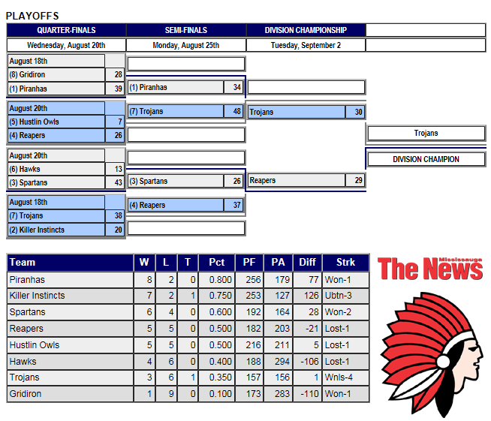

A Division
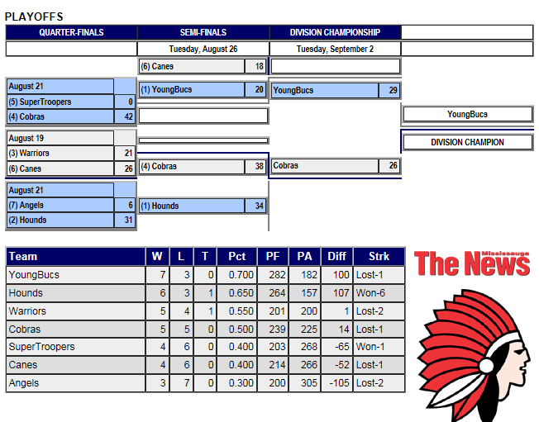
B Division

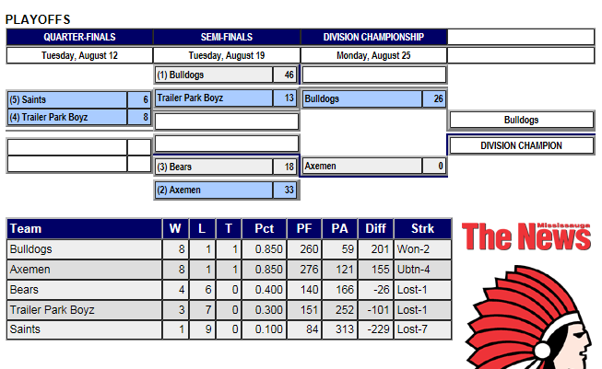

C Division
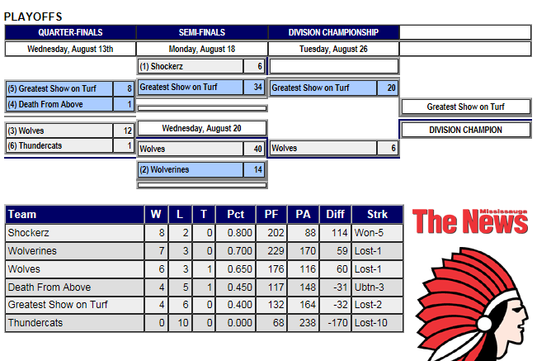
D Division
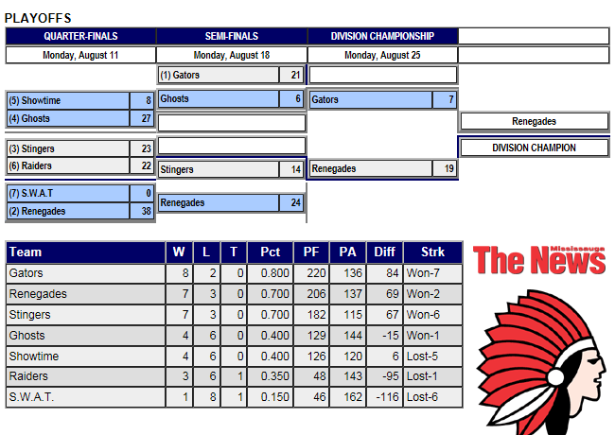

Based on the tabulated votes of the submitted game sheets of each regular season game, let’s also recognize the Most Valuable Player and the Most Sportsman like players from our last season:

Division | MVP 2014 | Sportsman 2014
AA | Marko Glavin  (Killer Instincts) | Delroy George  (Killer Instincts)
A | Derrick Ogden  (Warriors) | Peter Hoang  (Super Troopers)
B | Chadwin Bartley  (Saints) | Wayne Dimaline  (Axeman)
C | Kyle Badham  (GSOT) | Tharsan Sivaramalinghan  (ThunderCats)
D | Dieter Kusel  (Stingers) | Warsame Garad  (Raiders)
 | and from other recent seasons ...
Division | MVP 2013 | Sportsman 2013
AA | Adrian Ferenc  (Reapers) | George Ioannides  (Hawks)
A | Ryan Bachelor  (Canes) | Vic Carvalho  (Rack)
B | Ian Simpson  (Bears) | Gordon Shantz  (Super Troopers)
C | Sutharsan Sivasoothalingan  (ThunderCats) | Kevin O'Carroll  (ThunderCats)
D | Dieter Kusel  (Stingers) | Joe Kincaid  (Stingers)
Division | MVP 2012 | Sportsman 2012
AA | Josh Granek  (Cobras) | Devin Henry  (Spartans)
A | Melios Arsic  (Canes) | Justin Tang  (Canes)
B | Chris Rauch  (BullDogs) | Daryl Brady  (Bears)
C | Ben Bilz  (Hounds) | Phil Attrell  (Wolves)
D | Mark Mlakar  (Delta Squad) | Bill Chan  (Arrows)

  - 6. League Finances

League finances are in an acceptable state. As of 31-Dec-2014, the league’s bank account cash on hand balance was $7244.61.

- Approximately $700.00 of that amount has been subsequently spent in order to finalize the reconciliation of other expenditures needed and approved before tonight’s AGM. Specifically, expenses for room and equipment rental, printing costs, Executive Committee meetings, etc.

- For comparative purposes only, the league’s bank balance as of 31-Dec-2013 was $2696.76.

- One of the significant contributors to the 2014 surplus was the use of cheaper high school fields rather than the more expensive Valleys as a result of the Valleys being unavailable for use for an extended period of time.

- Other key contributors were additional non-team fee revenue streams (such as the proceeds from hosting the Brampton -2014 Trillium Tour event).

The unaudited accounting of the league’s 2014 actual expenses (as of 11-Mar-2015) is:

AGM-Exhibit: General Ledger At Close Of Previous Season

The financial forecast for the upcoming 2015 season is based on having a league of 36 teams. Total revenue forecasts are restricted to mandatory team fees only, with each team paying a $1750 team registration fee (fully supportive of all forecasted costs as well as the OPTION #1 scheduling strategy):

AGM-Exhibit: Budget Forecast For Upcoming Season

Each team’s registration fee of $1750.00 is payable in full prior to the conclusion of this meeting. If payment in full of the team registration fee is late, an additional $200 late fee charge is required. Late fee charges must be paid in full before the release of league’s schedule which is anticipated no later than 01-May-2015.

If a cheque-based payment is submitted on time, but subsequently fails to clear the bank, the above late fee may be applied. Regardless, a “bounced cheque” processing fee of $50 will be applied by the league to the offending team no matter what.

As usual, league size and composition is highly dependent on field and referee availability. At this point, the Executive Committee is hoping to have between 32-36 teams for the 2015 season and believes a sufficient number of field locations are available to operate.

$75 of this 2015 team registration fee might be returned to each team’s captain of record should the league not be successful in obtaining as many as desired lit-field locations and provided additional funds are not needed for any unseen expenses (regardless of the PAN-AM game concerns). For example, due to a lack of ample numbers of “white cap” capable referees as well as inconsistent support from the City of Mississauga for the acquisition of requested field location permits, the MTFL executive wishes to guide this league to the use of lit-field locations for all future growth in league-size scenarios.

Other refunded amounts from the team registration fee are possible during the season depending on which option of the PAN AM Games Mitigation Plan is deployed by the executive team. For example, under OPTION #2, each registered team would be entitled to a $200 refund. Refund payment is expected to occur on or before the team’s first regular-season game of play.

  - 7. 2015 Season – General Planning Particulars and Highlights

  - Team Roster – notification of change in roster (additions, deletions):
    - maximum 21 players; minimum 12 (league encourages at least 14)
    - game suspensions will be awarded for playing ineligible / unregistered players

  - Player Registration & Waiver Form:
    - all players new to the team need to fill it out
    - all players must be 18 years of age and male
    - may only be registered with one MTFL team
    - must meet playoff eligibility in order to play in playoffs: played (in attendance) at 3 reg. season games, 1 of which is in team’s first 6 games

  - Team Captains’ Responsibilities:
    - managing the team’s roster according to the League’s Team Roster Policy
    - communicating to the League any team roster changes (player additions or deletions)
    - ensuring each player has completed a Player Registration & Waiver Form and that it is on file with the League
    - promoting the League’s emphasis on ‘providing organized touch football in a safe, fun, competitive environment’
    - showing respect for officials and the difficult job they perform
    - ensuring players know the League’s touch football rules
    - ensuring players and fans know and abide by League rules and policies
    - ensuring the team is prepared to play each scheduled game:
    - members know when and where their next game is
    - members know how to access the league schedule online
    - game equipment is brought to each game (football, kicking tee, goal post pads, and numbered uniforms)
    - submitting the completed, current game sheet to the Head Official
    - being receptive to schedule changes – they are done only when necessary

  - 8. MEMBER Conduct

- Motto – providing organized touch football in a safe, fun, competitive environment.

- All members are to abide by the league’s Code of Conduct:

AGM Exhibit: Code of Conduct

- Player conduct before, during and after a game are subject to discipline.

- Ejection:
  - 3 OC’s same game – automatic ejection
  - an ejection does not require 3 OC’s; specifically, safety issue or player in-eligibility issue can be resolved via immediate ejections
  - players ejected may be asked to leave the game site
  - ejection involves suspension for future play until further notice (league disciplinary committee investigation)

- All players should shake the hands of the opposition as well as the officials at end of the game.

  - 9. Mississauga Officials Association (MOA) Updates/Feedback

- MTFL has a long-standing relationship with the MOA:
- positive and frequent dialogue, communication, and planning.
- George Zielinski and Peter Cover will be running training clinic prior to the start of the season. They will also be conducting assessment of as many as 30 different referee crew assignments during the season.
- If interested in joining the officiating group, please contact George Zielinski.
- Officials Incentive Program –for new player-referees - $75 over each of first 2 years - $150 total.
- Quality Assurance Program – evaluation program for referees – to improve quality and consistency of officiating.
- OA Liaison – Glenn Stevenson – contact to communicate questions and concerns.

The MTFL is willing to, for the betterment and consistency of the field of play, assist in bulk purchases of field cones, bean bags, etc. for referees who complete MTFL game assignments.

The MTFL now invites the MOA executives for a brief summary of any updates or other concerns and feedback they may wish to share this evening.

  - 10. City and Field Permits

At this time, the Executive Committee holds an informal and non-guaranteed understanding with the City of Mississauga that it will award a profile of field locations and game dates similar to that of the 2014 season. One difference was the number of field locations assigned for Thursday evenings; otherwise, actual field locations and game slot/dates are suitable for this season.

Due to PAN AM games, the use of fields in Brampton Toronto or Scarborough is a possibility for some games especially with OPTION #1. This may also mean the use of weeknights or weekend games not normally associated with this league’s regular-season schedule.

MTFL Executive committee has been in active dialogue with the City of Mississauga about future needs including the use of lit fields (whether grass or turf based). Again, at this time, the only issue to report is that Wildwood Park (e.g. Derry and 427, grass based) and Saint Marcellenius High School (e.g. Mavis and 401, turf based) are on the radar.

Finally, all league members are reminded that a turf-field location is currently more than ten times the cost to rent compared to any of the league’s current grass field locations.

  - 11. Marketing & Social Media

The league continues to build & sustain partnerships in the community for its promotional or operational needs:
- Mississauga News
- Chop Shop Sports
- T. Litzens Sports

The league also wishes to sustain a presence of social media (e.g. Facebook, Twitter and the www.mtfl.org website itself) as well as offer its members opportunities off the field (e.g. year-end party).

If you are interested in helping the league as a supplier, sponsor, advertiser or as person capable of “tweeting” league news and game results, please let the Executive Committee know that.

If you use/forward or make comment upon league announcements made thru social media or otherwise, be sure that your comments are not offensive or in poor taste. For example, comments should remain in-line with the league’s motto. Remember, that these forums are public ones. If you wouldn’t want your parent or child reading it, then don’t write it.

All are encouraged to promote the MTFL positively through these mechanisms to their team-mates, fans and the community as a whole.

In matters pertaining to or originating from the MTFL, inappropriate use of social media will be subject to league discipline.

  - 12. Other News of Interest

- TFOnt has changed eligibility requirements for persons wishing to attend a Trillium Tour event. For example, “hybrid” (or “merged”) teams will be allowed under some conditions and subject to some restrictions. MTFL “D” and “C” and “B” teams who have players interested in tournament action should contact league executive so they can be matched with other groups of players of other MTFL teams for possible combined entry to any number of tournaments that they may wish to participate in this season.

- In addition to TFOnt’s changes to tournament eligibility requirements, TFOnt also wishes to grow league member awareness to tournaments by asking leagues to consider scheduling (at least) one of their regular season games (from each of their divisions of play for which most teams currently do not participate in a tournament) at a local tournament. This year, for example, TFOnt has asked MTFL to consider scheduling one regular season game at “Brampton, May-2015” (30th or 31st).

A vote to identify any division specific tolerance for the consideration of this request by TFOnt will now occur. Only one representative of each veteran team (of each division implicated) in good standing may vote.

This vote is to determine compliance should, MTFL executive ensure playing conditions as well as costs of play are acceptable (e.g. similar to those of having this game played at normal MTFL game location at a normal evening of its Monday to Thursday offering).

From MTFL’s 2014 Div-B … Those For: Those Against:

From MTFL’s 2014 Div-C … Those For: Those Against:

From MTFL’s 2014 Div-D … Those For: Those Against:

- MTFL intends on serving as host for Trillium Tour “Brampton, May-2015”. Volunteers wanted and persons with “Smart Serve Card” are preferred. Persons interested are to contact John Schiebel by 15-Apr-2015.

- MTFL is considering hosting a TEXAS HOLD’em Poker Tournament (in late April or early May). Co-sponsoring teams or work places are welcome (for sourcing of “graft” prizing as well as proceeds sharing purposes). Persons or teams interested are to contact John Schiebel by 15-Apr-2015.

- Further MTFL web site automations for on-line player and team registration will be deployed this year. Team captains wishing to help develop or verify these automations should contact John Schiebel or Matthew Vincent.

  - Main Meeting Proceedings concluded

At this point, the Executive Committee opens the floor to questions or feedback from any person in attendance.

The Executive Committee reserves the right to defer a question (and/or the responses to it) to sometime after tonight and/or to the already next scheduled portion of tonight’s agenda being used for the communication of other more routine league details and concerns.

For those not wishing to remain after this question and answer period has occurred, a brief break will be held so you can dismiss yourselves from the room without interrupting the remaining proceedings planned for this evening.

B. Post AGM Supplementary Meeting begins

Other League Details and Particulars

      - Games
- Rules
    - uses Touch Football Ontario rules; however, there are some additional rules specific to MTFL:
        - 4 by 18 minute quarters
        - incidental head touch – 5 yard (versus 15 yard for non-incidental)
        - minimum player count to start game (6 players)
        - playoff entitlement
  - Game Sheets
    - use current sheet from the league’s website
    - submit game sheet to referee at half-time –only those present at time of game sheet submission are registered as ‘present’
    - players who arrive after game sheet submission may play but do not get credited with being in attendance
    - verify score at end of game
    - choose MVP and Sportsman for other team
    - captain signs sheet
  - Equipment
    - Goal Post Pads – mandatory
    - Team Uniforms – see Uniform/Jersey Policy

AGM Exhibit: Uniform Policy

    - Hard substance braces – must be fully covered (by soft material/wrap)
    - Jewelry – take it off or cover it fully with tape (as to reduce chances of injury to self or others)

  - 14. Divisional Alignment

Divisions are aligned based on several factors such as:
- the addition of new teams or the disbanding of veteran teams
- recruitment or loss of players by veteran teams
- performance and results from the previous season(s) in the MTFL
- performance in tournaments and other leagues
- team captain’s input on his team’s anticipated performance
Alignment of all divisions will be announced at least two weeks before the season starts.

  - Scheduling
Well in advance of the start of the regular season, each team should fill out the team schedule preference form.

AGM Exhibit: Schedule Preferences Form

The league will do its best to accommodate requests depending on other teams’ requests and various other factors. However, there is no guarantee that all of your own team’s preferences will be met at all times. The schedule must balance the preferences of all teams with the availability of its assets (fields, referee crews).

The season runs from approximately the middle of May to the beginning of September. Playoffs will be announced around the middle of June.

Game re-scheduling requests require a minimum of 72 hour advanced notice; one free change per season per team; additional change requests will cost $50 each payable in advance to the MTFL whether that request is awarded or not. Game re-scheduling requests for the final two games of your team’s regular season are not likely to be awarded as to ensure play-off schedule can be kept as published.

  - Player Registration

Player Waiver and Registration Form is posted on website.
- All new players and players changing teams as well as players returning after a year or more off must fill out the form.
- The form must be signed and then witnessed by the captain of the team. It also then must be handed into the league before that player attempts to play in any MTFL game.
- Players who are on record but move into Mississauga should fill out a new form to assist us with our residency assessment.
- Players who played on the same team last year do not need to fill it out.

  - Scores and Standings

Scores and standings are posted weekly; however, at the end of each game the team captain/representative should check the game sheet to be sure it has been filled in correctly. Furthermore, team members should check later in the week to ensure that the league’s website has been updated correctly with that final score.

Regular season ending ties are broken as per league policy/procedure.

AGM Exhibit: Regular Season Ending Standings Tie-Breaker Policy

Additional Data

  - Strategic Plan

The league executive is to champion the following objectives using sound, timely and transparent stewardship practices during all of its day-to-day as well as long-term planning and execution activities:

- Manage league finances to minimize the need to increase team registration fees by sustaining excellent supplier relationships, avoiding dependency on ancillary revenues (even if they are obtained through pre-approved and well planned fund-raising events) and, if applicable, accessing the league’s year-end surplus.

- Plan for and maintain a reasonably sized financial surplus. The surplus should be close to ‘the value of the total field permit costs from the previous season plus the anticipated rate increase for the next season’ (which has been typically 2 to 3% per annum). A larger surplus may be budgeted if it is pre-approved by the membership for the purposes of purchasing some asset or service which supports the league’s goals.

- Cultivate, train and retain a number of executive members consistent to the number of divisions of play. This will ensure that any opportunities for the perception of conflict of interest are minimized in all areas of league operations especially within the areas of player/team discipline and league finances.

- Recognize player, referee, member, supplier or partner achievements within games or other league sanctioned events including but not limited to: year-end parties, skills competitions, tournaments, league-organized social events (e.g. ARGO Nights), league or Citizen/Community award programs, etc.

- Promote the league through various means such as putting up information posters at local universities and colleges; encouraging social media use by the league membership (Facebook, Twitter); and encouraging coverage of games and/or interviews by local media (Mississauga News, magazines, local cable station).

- Invest appropriate amounts of league revenues into growing touch football at both the local and affiliated organization levels in well planned ways. This includes but is not limited to co-sponsoring events with other leagues or referee associations that are also supportive of having game officials who are accredited, regularly assessed and afforded training for improvement. It may also include sponsoring or providing donations to other football leagues of interest as well as supporting the development of tournament capable teams (from MTFL member teams) by sharing portions of any ancillary revenues generated by this league.

- Communicate to members and fans alike with social media programs continually emphasizing adherence to the league’s mission, policies and code-of-conduct. This includes having an on-line presence and automations geared towards sustaining long-term relationships between the league and each individual person of interest to it. Furthermore, a goal of sustaining this league at a size of 28 teams or larger (year over year) enables reasonable portions of the team registration fees to be designated to factors of distinction that are deemed key to the sustaining of the successful brand and image of this league.

- Cultivate the appropriate relationships with City officials responsible for the creation or award of access to new or modified field assets with a specific goal of obtaining one additional (grass or turf based) lit-field location. Specifically, the league can be more efficiently operated on as few as two lit-field locations and be less restricted by the total number of game officials or their level of qualification.

- Assess the strategic plan, league constitution, by-laws and policies at the conclusion of a season as to determine what, if any, modifications should be considered for approval in the league’s next AGM whilst ensuring that all decision-making processes remain based on democratic principles.

  - 18. Historical Data - Last Eight Years of Operation

The following (un-audited) historical data is indicative of the league’s recent health. It is meant to be used for trending, forecasting or validating league decisions (year over year).

Factor | 2014  (43rd season) | 2013  (42nd season) | 2012  (41st season) | 2011  (40th season) | 2010  (39th season) | 2009  (38th season) | 2008  (37th  season) | 2007  (36th season)
Year Ending Net Surplus | $7244.61 | $2696.76 | $1197.79 | $4121.45 | $8753.21 | $13953.19 | $9372.65 | $4765.29
Liabilities – performance bond monies retained on top of the Net Surplus | None. | $6000 | $6600 | $7400.00 | $6600.00 | $7000.00 | $5800.00 | $5600.00
Field Permit Costs | $5366.69 | $3915.81 | $5556.65 | $5242.26 | $4724.95 | $4518.68 | $2576.89 | $4790.84
Per Team Registration Fee | $1600 | $1600 | $1450 | $1300 | $1250 | $1200 | $1200 | $1100
Total # of Teams | 33 | 30 | 33 | 37 | 33 | 35 | 29 | 28
Total # of Teams retained from previous year | 28 | 27 | 27 | 30 | 27 | 27 | 25 | 23
Total # of Players | 644 | 532 | 570 | 659 | 589 | 620 | 527 | 492
Residency Compliance with City of Mississauga  Note: in CY2009 league became home to many Trillium Teams. | ~20% | ~26% | ~28% | ~29% | ~33% | ~31% | ~32% | ~29%
Total # of Games Requiring a Disciplinary Committee to be formed  Note: Player awards instituted in CY2012. |  | 2 | 9 | 17 | 7 |  | 1 | 7
Total # of Injury Incidents Requiring or Implicated Emergency Responders | Zero | One  (ankle) | Zero
Total # of Legal Suits | None. | None. | None. | None. | None. | None. | None. | None.
Total # of Executive Committee Members | 4 | 4 | 3 | 4 | 4 | 5 | 4 | 4
Total # of Divisions of Play | 5 | 5 | 5 | 5 | 5 | 5 | 4 | 4
Total # Trillium Tour Events Hosted | 1 | 1 | 1 | 2 | N/A | N/A | N/A | N/A
Total # of declared Trillium Tour Tournament Teams (and that attended at least one tour tournament event) | 10 | 8 | 7 | 8 | 8 | 8 | 5 | 6
Total # of New Player Profiles Received | 50 | 36 |  |  |  |  | 33 | 30
Total # of New Player Profiles that described themselves as “QB” capable | 9 | 4
Ancillary revenues (from 50/50 draws, ARGO ticket sales, proceeds from hosting poker or football tournaments, etc.)? | Yes | Yes | Yes | Yes | Yes | Yes | No | No

19. Calendar of Executive Team’s Tasks Each Season

Typical executive team member tasks (with typical maximum durations in hours of effort spent) are listed in the block diagram below.

Jan | Feb | Mar | Apr | May | Jun | Jul | Aug | Sep | Oct | Nov | Dec
T1: Website Maintenance: updates for info posted on site; re-organizing info such as team photos and online yearbook)
[2 hour per week]
T2: General Email Correspondence: recruitment of new teams / new players; league purchasing needs and agreements and bank transaction tracking / reporting, replies to general enquires.
[1.5 hour per week]
T3: League Promotion: interface with high schools, colleges, universities as well as other organizations and the media.
[0.5hours per week]
T4: Online Field Reservation  [ 6 hours] |  | T5: Payment of Field Permits  [4 hours] | T6: Divisional Allocation  [16 hours] | T7: At game site: Team/Player/Game Monitoring; MOA quality monitoring; Photography; Prize distribution  [1.5 hours per week] |  |  |  |  | T8: MTFL and MOA Liaison Year-End Reports  [30 hours]
 | T9: AGM and preparations  [48 hours] |  | T10: Schedule Creation + Verification  [24 hours] |  |  |  | T11: Year-End Party  [6 hours]
 | T12: Payment of Affiliation and Insurance Fees  [2 hours] |  |  |  | T13: Special Event (e.g. ARGO) ticket sales and distribution  [as required hours]
 |  | T14: Team Fee Deposits & Late Payments  [5 hours] |  | T15: Player Discipline: investigation, disposition and enforcement.  [1.5 hours per week]
 | T16: Team Finance & Record of Play Update  [8 hours] |  |  | T17: Schedule Modifications: game cancelations or otherwise re-schedule requests.  [1.5 hours per week]
T18: Game Sheet Attendance: database updates and team roster change tracking.
[1.5 hours per week]
Jan | Feb | Mar | Apr | May | Jun | Jul | Aug | Sep | Oct | Nov | Dec
 | LEGEND | Participants |  | Activity
 |  | Exec. Committee, League Teams |  | Prepare for team rep events.
 |  | Exec. Committee |  | A home activity or a meeting with 3rd party.
 |  | Volunteer, Div. Rep, 3rd Party Supplier |  | Weekly duration; may require visits to actual game sites.
 |  | Exec. Committee |  | Assisted by online collaboration tools (telecoms, WebEx).
 |  | Exec. Committee |  | Home computer and home phone activities.

The Executive Committee will ensure the various roles needed to run the league are assigned before the start of the regular season. Those roles include but are not limited to:

Director of Purchasing and Finance Director of Record Retention
Director of Discipline Director of Marketing and Media Relations
Director of Website Maintenance Director of League Communications
Director of Scheduling Director of Player/Team Registration
Director of Referee Relations

Members of the executive will track their total hours of actual volunteer for approved tasks and report them to the President and VP-Finance on a monthly basis (minimally). The following calculator and log sheet can be used for such purposes.

AGM Exhibit: Operations Task Calculator and Actual Hours Log

20. OTHER EXHIBITS, FORMS or PRESENTATIONS of INTEREST

AGM Exhibit: New Team Roster Application Form

AGM Exhibit: Player Waiver Form

AGM Exhibit: Exemplary Discipline Process

AGM Exhibit: The official MTFL Artwork / Logo
TBD.

AGM Exhibit: Media Handout #1 – Key Contact Information and Benefits Overview

AGM Exhibit: Media Handout #2 – How To Register And Play Football

AGM Exhibit: PAN AM GAMES Mitigation Plan

21. URL/WebSITE of INTEREST

MTFL ... www.mtfl.org

Touch Football Ontario ... www.tfont.com

My Tournament (scores and team attendance) ... www.mytournament.ca

Rules of the game ... TBD.

